In this project i will plan and structure how the event ticket system will work using diagrams and other designs using the object-oriented approach. We will do this to see a visual representation of how the project is designed to function. Planning and making diagrams will save you a lot of time when doing the project. This is because you already have a proven plan. You can work from that to do the project. This ensures that each role has the correct responsibilities and that they are all satisfied before putting it on to the public.

1 | View List of Upcoming Events or View Scheduled Shows by Date
2 | Select Seats(s) from a Seating Chart
3 | Hold the Seats While They Complete Their Selection
4 | Purchase Selected Seats
5 | Divide Seating Sections by Ticketing Services Over a Date Range
6 | Only Allow Ticketing Agents to Sell from Their Own Area
7 | Pricing Structure Containing adult, student, child and senior citizen, Discounts are per show.
8 | Unique Discounts for Each Showing
9 | The venue manager must be allowed to cancel reschedule or add events and shows and allow changes to the maximum seats per customer value for each show
10 | Customers must provide a valid sign in and password.
11 | Customer Profiles must include address information
12 | When Selecting Seats customers are displayed with a floor chart of the concert hall, it should be coloured with the status of the chair, available, held or sold.
13 | Selecting a seat puts it on hold
14 | Deselecting a seat takes it off hold
15 | Users should be limited to a maximum of seats, specified per show.
16 | Automatic Seat Selection using a price range and number of seats desired, then showing appropriate seats
17 | If no seats are available display appropriate messages
18 | Volume discount should be available per show
19 | Tickets must be tracked separately, with its price, applied discount and seat assignment
20 | Credit card are the only thing accept must be validated, all credit cards are approved
21 | Agent provides customer information selects events same as consumers but can only see their seats
22 | Agents can see the total number of tickets sold for the currently displayed show or all shows in the date range.
23 | Once seats are held for up to 5 mins where the user is prompted to continue if they do not an alarm sounds every minute for 3 minutes then the held seats are released, this applies to agents and consumers

Class diagram
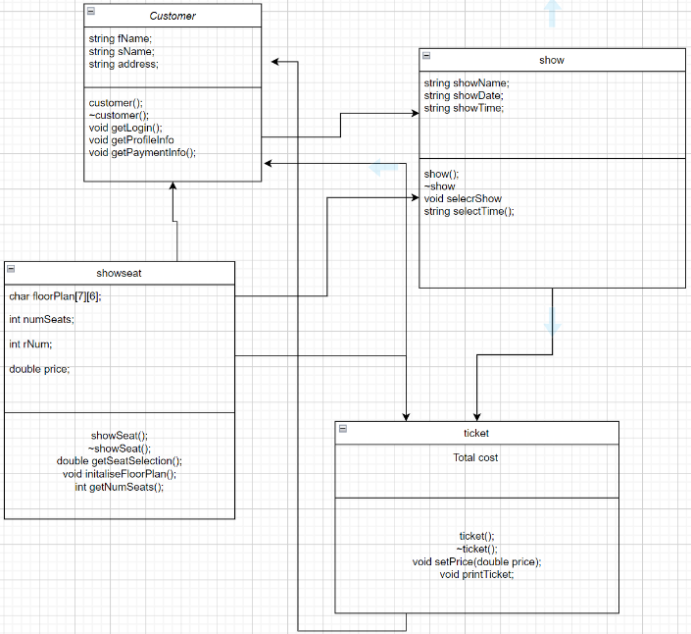

Sudo code:
Customer.h
start function.
customer
~customer
getLogin
GetProfileInfomation
FirstName - string
Surename - string
Address details - string
End function
start function.
create FirstName
create SureName
create address
end function

function ~customer
start function
end function
function getLogin
start function
username is a string
password is a string
display "LOG IN" messege
display "welcome to the bucks cinema" message
display "please log in" message
display "enter username" message
assign the user's details
display error message “only if username is lower than required amount”
display "re-enter your username" message
end while
display "enter password" message
fetch the user's input
assign display error message “if password is lower than required letters or numbers”
display "re-enter your password" message
end function
start function
display "PROFILE INFORMATION" message
display "Enter your first name" message
initialises the fName variables into the class variables
display "Enter your first name" message
fetches the user's input and stores to sName
display "Enter your Address" message
fetches the user's input and stores to Address
end function

class show:
start function
public variables:
show()
~show()
Void - selectShow
string - selectTime

protected variables:
showName - string
showDate - string
showTime - string
end function

function show
start function
Creates showName to empty string
Creates showDate to empty string
Creates showTime to empty string
end function

function ~show
start function
end function

function selectShow
start function
output message "SELECT AN UPCOMING SHOW"
output message of the first show
output message of the second show
output message of the third show

output message "select show "
system fetches the user's input
If user inputs wrong show number
asks the user again to input a valid show number
end while

switch (ch)
1 : OUTPUT: showName, showDate
2 : OUTPUT: showName, showDate
3 : OUTPUT: showName, showDate
end switch

class selectTime
start function
end function

class showSeat:
start function

public variables:
showSeat()
~showSeat()
initaliseFloorPlan() - void
getNumSeats - int
getSeatSelection - double

private variables:
displayFloorPlan - void
calculatePrice - void

protected variables:
floorPlan - char
numSeats - int
rNum - int
price - double
end function

function showSeat
start function
initalises row seats using for loop
initalises column seats using for loop
displaying each column by row

sets numSeats
sets rNum
sets price
end function
function initaliseFloorPlan
start function
initalises row seats using for loop
initalises column seats using for loop
displaying each column by row to 'S'
end function

function getNumSeats()
start function
output message "SELECT AVALAIBLE SEATS"
output message "How many tickets are you looking into purchasing?"
fetch user's input
end line

class ticket:
ticket
~ticket
setPrice - void
printTicket - void

function ticket
start function
creates totalCost to zero
end function

function printTicket
fetches price, showName, showDate, showTime, numSeats, fName, sName, address as parameters
start function
output "YOUR TICKETS ENJOY THE MOVIE"
output "Show:" retrieve user input to showName
output "Date: " retrieve user input to showDate
output "Time: " retrieve user input to showTime

output "number of seats" fetches user input to numSeats
output "Total cost: " fetches user's input to price
output "Ticket purchaser: " fetches the user's input fName and sName
output "Postal address: " fetches user's input to address
end function

Actual code
Coursework.cpp:

#include <iostream>
#include <string>
#include "showSeat.h"
#include "show.h"
#include "customer.h"
#include "ticket.h"
using namespace std;

int main()
{

string a, b, c, f, g, h;
int d;

double e;

char ch, terminator;

showSeat SEAT;
show SHOW;
customer CUST;
ticket TICK;

CUST.getLogin();
CUST.getProfileInfo(f, g, h);

// Displays Main Menu

system("CLS");

cout << "\n~~~~~~~~~~~~~~~~~~~~~~~~~~~~~~~~~ MAIN MENU ~~~~~~~~~~~~~~~~~~~~~~~~~~~~~~~~~~~\n" << endl;
cout << "1. Buy tickets for upcoming shows" << endl;
cout << "2. Log out\n" << endl;
cout << "Please enter a menu choice number: ";
cin.get(ch);

while (ch != '1' && ch != '2')
{
cin.clear();
cin.ignore(100, '\n');
cout << "Please select a valid menu choice number: ";
cin.get(ch);
}

if (ch == '2')
{
return EXIT_SUCCESS;
}

do
{
SHOW.selectShow(a, b);
c = SHOW.selectTime();

do
{
cout << "\n Are you happy with your choice (Y = Yes, N = No)?: ";
cin.get(ch);
} while (ch != 'Y' && ch != 'y' && ch != 'N' && ch != 'n');
cin.get(terminator);
} while (ch == 'N' || ch == 'n');

SEAT.initaliseFloorPlan();
d = SEAT.getNumSeats();
e = SEAT.getSeatSelection();

TICK.printTicket(e, a, b, c, d, f, g, h);

return EXIT_SUCCESS;
}

#pragma once

#include <iostream>
#include <iomanip>
#include <string>
#include <Windows.h>

using namespace std;

class customer
{
public:
customer();
~customer();
void getLogin();
void getProfileInfo(string& fName, string& sName, string& address);
void getPaymentInfo();

protected:
string fName;
string sName;
string address;
};
customer::customer()
{
fName = "";
sName = "";
address = "";
}

customer :: ~customer()
{
}

void customer::getLogin()
{
string username;
string password;

cout << "\n~~~~~~~~~~~~~~~~~~~~~~~~~~~~~~ LOG IN ~~~~~~~~~~~~~~~~~~~~~~~~~~~~~~~~\n" << endl;
cout << "\n Welcome to the Bucks Cinema!" << endl;
cout << " please log in." << endl;

cout << "Enter username: ";
getline(cin, username);

while (username.length() > 10)
{
cout << "Your username has be no more than 10 characters." << endl;
cout << "Please re-enter your username (has to be no longer than 10 characters): ";
getline(cin, username);
}

cout << "Enter password: ";
getline(cin, password);

while (password.length() > 10)
{
cout << "Your password should be no more than 10 characters long." << endl;
cout << "Please re-enter your password (has to be no longer than 10 characters): ";
getline(cin, password);
}
}
void customer::getProfileInfo(string& fName, string& sName, string& address)
{
system("CLS");
cout << "~~~~~~~~~~~~~~~~~~~~~~~~~~ PROFILE INFORMATION ~~~~~~~~~~~~~~~~~~~~~~~~~~~\n" << endl;
cout << "Please input your First Name: ";
getline(cin, fName);

this->fName = fName;

cout << "Please input your Surname: ";
getline(cin, sName);

this->sName = sName;

cout << "Please input your Address: ";
getline(cin, address);

this->address = address;

}

#pragma once

#include <iostream>
#include <iomanip>
#include <string>

using namespace std;

class show
{
public:
show();
~show();
void selectShow(string& showName, string& showDate);
string selectTime();

protected:
string showName;
string showDate;
string showTime;
};

//constructor
show::show()
{
showName = "";
showDate = "";
showTime = "";
}

//destructor
show :: ~show()
{
}

// customer selects upcoming show
void show::selectShow(string& showName, string& showDate)
{
char ch;
char terminator;

system("CLS");
cout << "\n~~~~~~~~~~~~~~~~~~~~~~~~~~~~~~~~~ SELECT AN UPCOMING SHOW ~~~~~~~~~~~~~~~~~~~~~~~~~~~~~~~~~~~~\n" << endl;

cout << "1. Jurassic World (20/05/2018)" << endl;
cout << "2. Harry Potter (21/05/2018)" << endl;
cout << "3. Fast and Furious (22/05/2018)" << endl;

cin.clear();
cin.ignore(100, '\n');

cout << "please select a show number: ";
cin.get(ch);

while (ch != '1' && ch != '2' && ch != '3')
{
cin.clear();
cin.ignore(100, '\n');
cout << "Please selct a show: ";
cin.get(ch);
}

switch (ch)
{
case '1': showName = "Jurassic World", showDate = "20/05/2018";
break;
case '2': showName = "Harry Potter", showDate = "21/05/2018";
break;
case '3': showName = "Fast and Furious", showDate = "22/05/2018";
break;
}

this->showName = showName;
this->showDate = showDate;

cin.get(terminator);

}

// customer selects 12am or 8pm showing
string show::selectTime()
{
char ch, terminator;

system("CLS");
cout << "~~~~~~~~~~~~~~~~~~~~~~~ SELECT TIME ~~~~~~~~~~~~~~~~~~~~~~\n" << endl;
cout << "1. 12am" << endl;
cout << "2. 8pm" << endl;

cin.clear();
cin.ignore(100, '\n');
cout << "Select a time: ";
cin.get(ch);

while (ch != '1' && ch != '2')
{
cin.clear();
cin.ignore(100, '\n');
cout << "Selct a valid time number: ";
cin.get(ch);
}

switch (ch)
{
case '1': showTime = "12am";
break;
case '2': showTime = "8pm";
break;
}

return showTime;
cin.get(terminator);

}

#pragma once

#include <iostream>
#include <iomanip>
#include <string>

using namespace std;

class showSeat
{
public:
showSeat();
~showSeat();
void initaliseFloorPlan();
int getNumSeats();
double getSeatSelection();

private:
void displayFloorPlan(int r, int c);
void calculatePrice(double& price);

protected:
char floorPlan[7][6];
int numSeats;
int rNum;
double price;
};

showSeat::showSeat()
{
for (int r = 0; r < 7; r++)
for (int c = 0; c < 6; c++)
floorPlan[r][c] = '0';

numSeats = 0;
rNum = 0;
price = 0;
}

showSeat:: ~showSeat()
{
}

void showSeat::initaliseFloorPlan()
{
for (int r = 0; r < 7; r++)
{
for (int c = 0; c < 6; c++)
{
floorPlan[r][c] = 'A';
cout << setw(5) << floorPlan[r][c];
}
cout << endl;
}
}

int showSeat::getNumSeats()
{
//system("CLS");

cout << "\n~~~~~~~~~~~~~~~~~~~~~~~~~ SELECT SEATS INTERACTIVELY ~~~~~~~~~~~~~~~~~~~~~~~~~\n" << endl;

do
{
cin.clear();
cin.ignore(100, '\n');
cout << "How many tickets would you like to purchase (max. 8)?: "; // prompts customer to enter no. of tickets
cin >> numSeats;
cout << endl;
} while (numSeats != 1 && numSeats != 2 && numSeats != 3 && numSeats != 4 && numSeats != 5 && numSeats != 6 && numSeats != 7 && numSeats != 8);
return numSeats;
}

double showSeat::getSeatSelection()
{
int row, column;
int counter = 0;

system("CLS");
cout << "~~~~~~~~~~~~~~ KEY ~~~~~~~~~~~~~\n" << endl;
cout << " A = Avaliable seat\n" << endl;
cout << " H = Hold seat\n" << endl;

while (counter < numSeats)
{
cout << "Please enter the row number (0-6) for seat: ";
cin >> row;

while (row != 0 && row != 1 && row != 2 && row != 3 && row != 4 && row != 5 && row != 6)
{
cout << "Please re-enter the row number (minimum 0-6 max) for seat: ";
cin >> row;
}

cout << "Please enter the column number (minimum 0-5 max) for seat: ";
cin >> column;

while (column != 0 && column != 1 && column != 2 && column != 3 && column != 4 && column != 5)
{
cout << "Please re-enter the column number (minimum 0-5 max) for seat: ";
cin >> column;
}

displayFloorPlan(row, column);
counter++;
calculatePrice(price);
}

cout << " Your total ticket price is " << price << "!";

return price;
}

void showSeat::calculatePrice(double& price)
{
price += 18;
this->price = price;
}

void showSeat::displayFloorPlan(int r, int c)
{
for (int a = 0; a < 7; a++)
{
for (int b = 0; b < 6; b++)
{
if (r == a && c == b)
{
floorPlan[a][b] = 'H';
cout << setw(5) << floorPlan[a][b];

}
else
{
floorPlan[a][b] = 'A';
cout << setw(5) << floorPlan[a][b];
}
}
cout << endl;
}

}
Ticket.h

#pragma once

#include <iostream>
#include <iomanip>
#include <string>
#include <Windows.h>

using namespace std;

class ticket
{
public:
ticket();
~ticket();
void setPrice(double price);
void printTicket(double price, string showName, string showDate, string showTime, int numSeats, string fName, string sName, string address);

protected:
double totalCost;
};

ticket::ticket()
{
totalCost = 0;
}

ticket :: ~ticket()
{
}

void ticket::printTicket(double price, string showName, string showDate, string showTime, int numSeats, string fName, string sName, string address)
{
system("CLS");

cout << "\n~~~~~~~~~~~~~~~~~~~~~~~~~~~~ YOUR TICKETS ~~~~~~~~~~~~~~~~~~~~~~~~~~~~\n" << endl;

cout << "==========================================================================" << endl;
cout << "================= The Bucks Cinema ===============" << endl;
cout << "============================= Enjoy the Movie ! =========================" << endl;

cout << "Show: " << showName << endl;
cout << "Date: " << showDate << endl;
cout << "Time: " << showTime << endl;
cout << "==========================================================================" << endl;
cout << "Number of seats: " << numSeats << endl;
cout << "Total cost: " << price << endl;
cout << "Ticket Purchaser: " << fName << " " << sName << endl;
cout << "Postal address: " << address << endl;

cout << "===========================================================================" << endl;
cout << "==========================================================================\n\n" << endl;
}
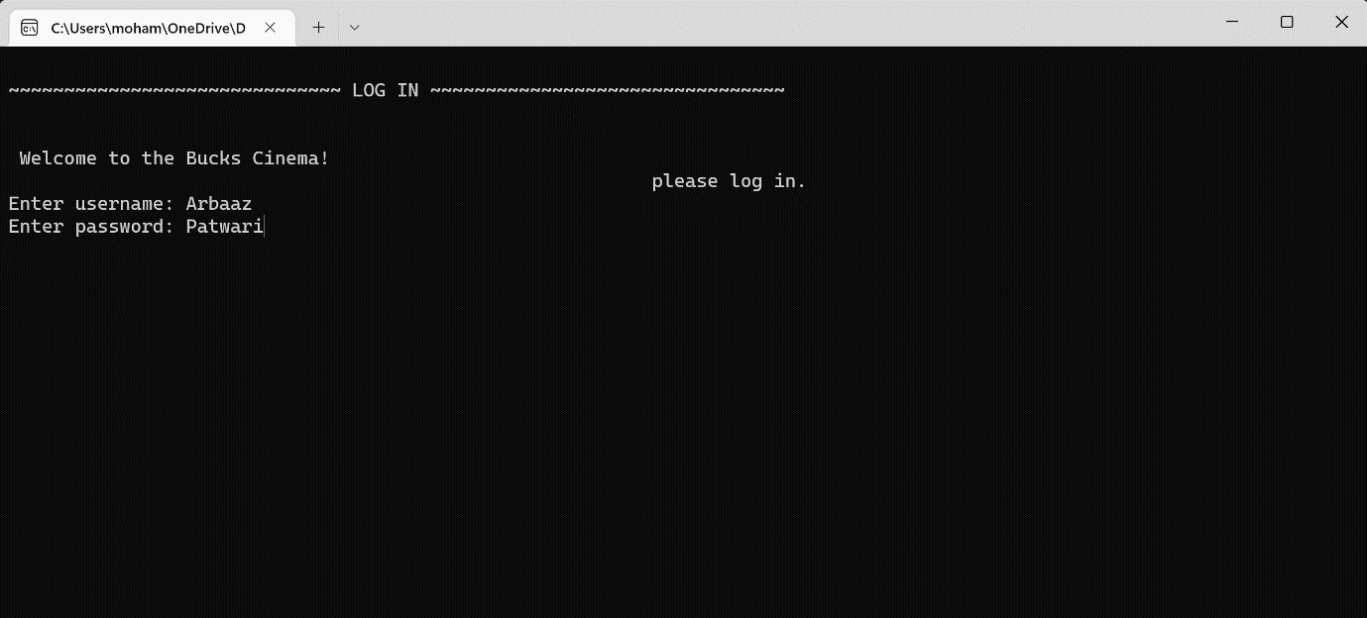
Test cases/screenshots
Test 1: program starts, and it wants you to enter a username and password.
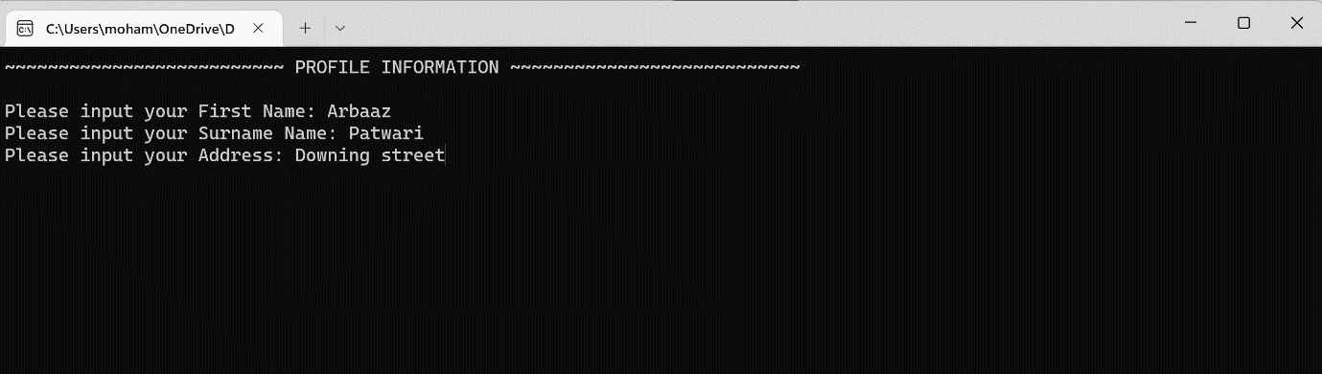
Test 2: Systems wants you to enter firstname,surname and your address details for your profile information.

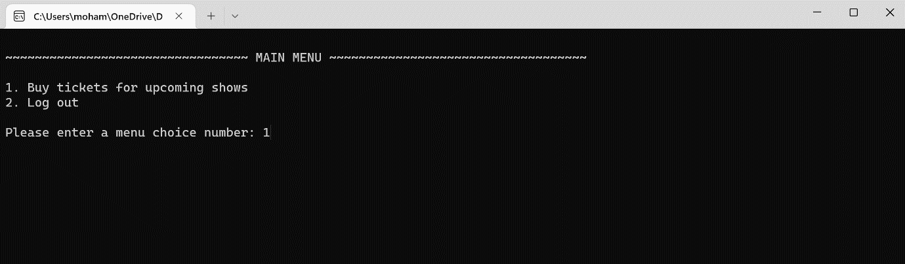
Test 3: Once profile details are entered you will be sent to the main menu where it will ask whether you would like to “Buy tickets for upcoming shows” or “Log out” and you can choose any of these options buy pressing 1 or 2

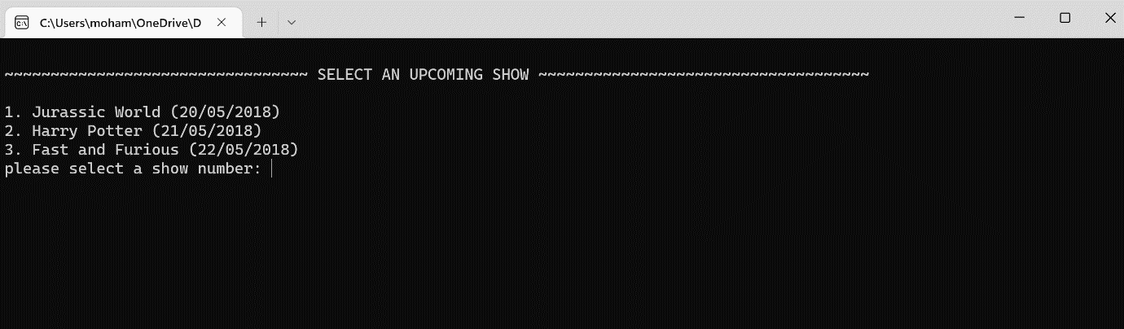
Test 4: When 1 is selected you will be sent to the “Select an upcoming show” where you will have a choice of 3 shows that you can choose from and you can select a number depending on what show you would like to see.

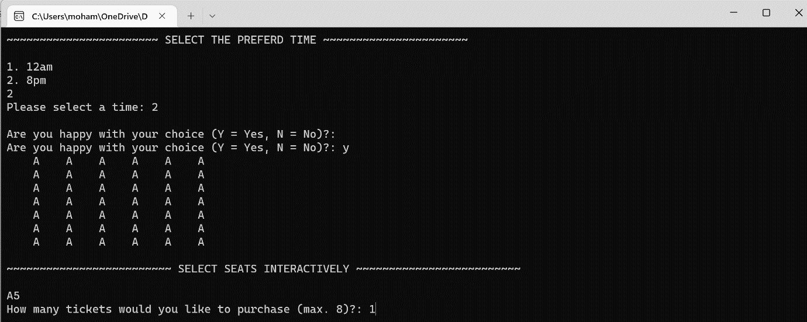
Test 5: After you select a show to watch you will be presented to the “select the preferred time” screen which then you can select a time as well as select your seats and find out whether their available or not and how many tickets you can purchase and the max amount.

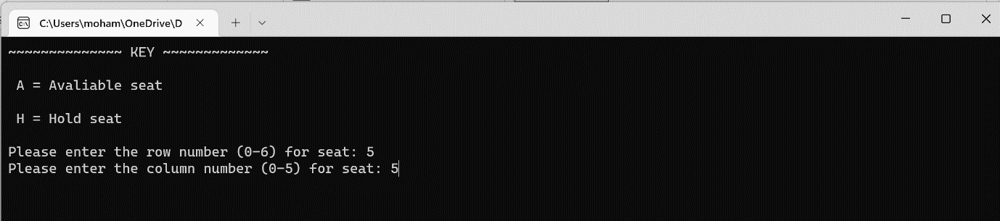
Test 6: once you select the available seats that u like you can choose the “row number” and the “column number”which they all have the minimum and max numbers.

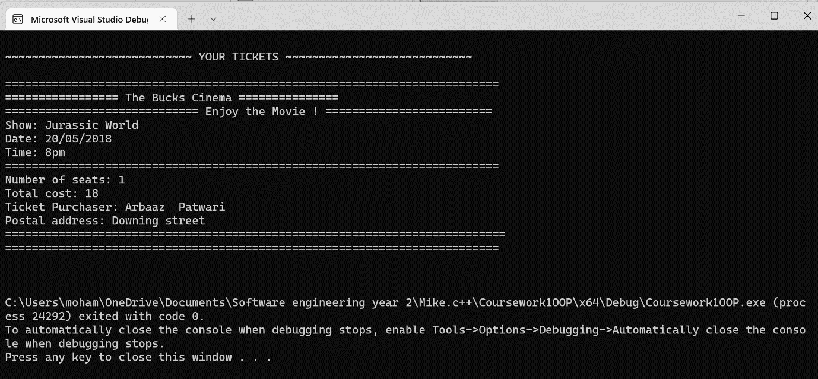
Test 7: Once you have chosen the row number as well as the column number you receive to your “tickets” which has all the details that u previously entered.

Evaluation
The work that I have submitted works when you load it up on the debug you can choose 1 out of three movies as well as being able to choose what seat column and row you would like. The coding is also clear and fine as it does show everything that has been done. One thing that I can improve on is to show some seats as taken so it becomes more realistic and if you try to take a taken seat it will refuse it.

